Yana’s Sample Organizer
Research Question
How did Romans live their Daily Lives?
Source  URL | Fact/ Image/ Quote/ etc. | Analysis  Description  Why is this important?  What conclusions can I make? | Reflection  This makes me wonder…  A question I have because of this
Article from National Geographic  http://science.national geographic.com  /science/archaeology/ | 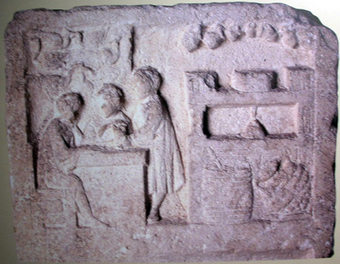 | This is a clay tablet depicting ancient Romans eating at a “fast food” place. You can tell that it’s fast food because only one of the people is sitting all the other ones are standing…like a bar. This means that fast food joints aren’t some new phenomena. I guess people from way back then aren’t all too different from us. They also needed food on the go because they probably had busy lives. | This makes me wonder what kind of food was served at places like this.  Did all classes eat fast food or just the lower classes?

