Dress your writing up!!!
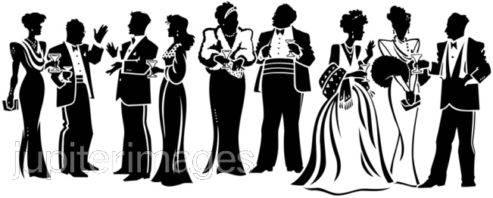
Strong writers adjust their writing for different purposes. The way we speak to our friends is different than we speak to our parents and our teachers. Even on paper.
How to Make Your Writing More Formal:
Do this | Don’t do that
- Be precise: use accurate and specific language and adjectives  - Write in present tense ( for all literature)  - Proper punctuation commas, periods, etc.  Avoid run- ons.  - Use transitional words to link information together neatly. | - Do Not use contractions: don’t can’t = can not  - Avoid metaphorical language “ break his heart” be as literal as possible  - Spell check please!!!  - Don’t ask your reader rhetorical questions.  - Avoid personal pronouns: you, us, we  - Avoid meaningless words  “had” “like”  - No “I think” “I feel”  - Do not abbreviate  - Avoid crazy font

