Unit: Research / TED Talks Investigate Discern
EQ: What is “research”?

5/12
Aim: How can we investigate mentor texts in order to plan our own work?

Mind Spark:

When I was a kid, I loved…
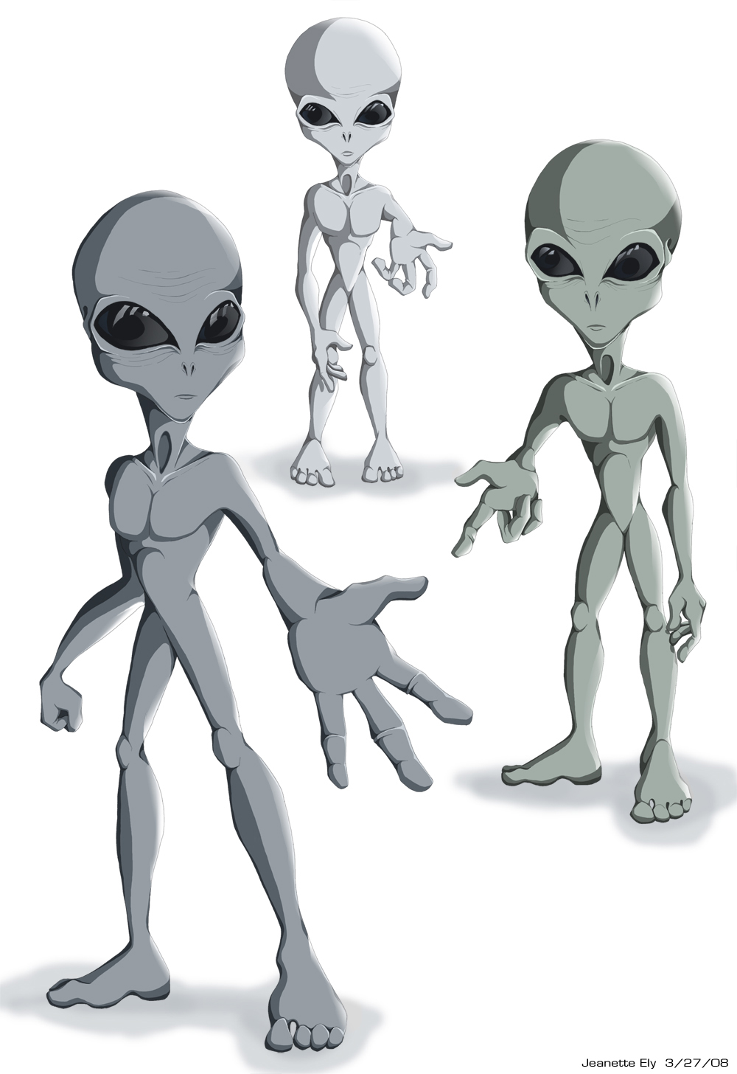

What were you obsessed with when you were little and would read about all night?!

As we get older, why do we stop “researching” our world and our interests?

Purpose  Ex: What is the presenter’s goal?  What big idea is the presenter expressing? | Structure  Ex: How does the presenter start and end his ideas?  What steps does he take to deliver the idea? | Content  Ex: What type of information is the presenter sharing?  What different sources is the presenter using? | Voice  Ex:  What is his tone?
- Being happy and healthy is equally important to education | - Started with a general statement specific  - Asked questions of the audience  - ( rhetorical question)  - personal experiences | - Photographs  - Diagrams  - ( made himself)  - referred to other TED TALKS  - Scientific evidence  - Interviews | - Humor  - Passionate  - Conversational  - Connected with audience  - Confident  - ( motivated)  - Facial expressions
Task: Watch this awesome video of a kid delivering a Ted Talk. We are watching this video with a goal! We need to figure out the purpose, the structure, the content, and the “voice” of a Ted Talk so that we can start to think about our own Ted Talk.

Independent Work:

- Continue this mentor text inquiry with other Ted Talks.

- Visit my website for links to especially awesome talks or go to the Ted Talk website to explore!

- Make sure you are watching with a goal and filling out information as you move through the video. It is okay to pause a video as you watch to write something down!

What do you want to investigate for the TED Talk?

Homework: Watch more Ted Talks! Start thinking about some topics you might want to investigate for this unit. Record in your notebook.

If you struggled with the homework over the weekend, I am staying after school today for 30 mins. I will be delivering a mini-lesson on crafting a counter-argument and anything else you need!

