Unit: Research / TED Talks Investigate Discern
EQ: What is “research”?

5/13
Aim: What is it about our world that makes you passionate?

Mind Spark:
- What videos did you watch for homework?
- What did you like about them?
- Any ideas for your own piece?

I ?

Strong researchers are passionate about the topic they study. They have a personal connection and a stake in their research.

- What is your topic of interest?
- What is your personal connection to this idea?
- Why are you interested in this?
- What experiences have brought you to this topic?

Take time to free-write and collect your thinking…

What do you already know about the topic… what else is there to know? If you’re stuck between several topics, use this chart to see which topic pushes you to ask the most interesting questions?

Example:

Topic | I know some things about this topic like… | Questions I have and topics I want to know more about:
Roman  Empire | Architecture  Inventions  Rulers/Emperors  YOU CAN ALSO FREEWRTE THIS PART… REALLY GETS THE IDEAS FLOWING | Tips!  Who?  What?  Where?  When?  Why?  What was the  social and family structure of Roman families?  What religion/gods did Romans worship? Did they go to a temple? How often?  What did school look like in the Roman Empire? Who got to go to school?

- Look at the questions you are wondering about. Identify your subtopics.
b) Reflect.
What topics lives in my questions?

- Family
- Religion
- Education

What do all these topics have in common? What larger category do they belong to?

Questions I have and topics I want to know more about:
What was the
social and family structure of Roman families?

What kinds of jobs did Romans have?
I’ve looked at my questions and it seems that I really want to know more about the everyday life of a Roman… I know the stuff we learned in history class, but I want to know what it was like to live a day as a Roman.

Preliminary Research Question:
How did Romans live their daily lives?

What religion/gods did Romans worship? Did they go to a temple? How often?

Who went to school? What was school like?

Homework:
Please come in with a working research question.

Developing a research question:

Have a student

Be discerning and purposeful about the type f information your including

Unit: Research / TED Talks Investigate Plan
EQ: What is “research”?

5/13
Aim: How do researchers organize their information?

Mind Spark:
- I’m a mess sometimes…

Strong researchers organize their information in order to prepare for their projects. Researchers take time to think about the information they collect in order to figure out what it means to them and their own work.

Sample Graphic Organizer

How did Romans Live their Daily Lives?

Source | Fact/Image/ See google doc. | Analysis  Importance/ Why is this important?  What conclusions can I make? | Reflection  This makes me wonder…  A question I have because of this
Article from National Geographic  http://science.national geographic.com  /science/archaeology/ | 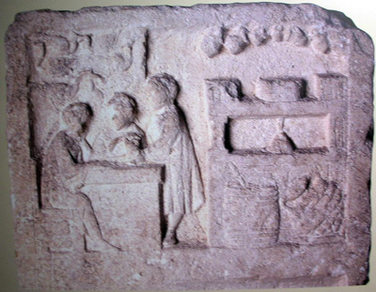 | This is a clay tablet depicting ancient Romans eating at a “fast food” place. You can tell that it’s fast food because only one of the people is sitting all the other ones are standing…like a bar. This means that fast food joints aren’t some new phenomena. I guess people from way back then aren’t all too different from us. They also needed food on the go because they probably had busy lives. | This makes me wonder what kind of food was served at places like this.  Did all classes eat fast food or just the lower classes?

Research Question:
Independent Work:
- Create an organizer in order to organize your information

- Make sure to analyze and reflect as you collect, don’t just copy +paste

- You do not need to include every source you visit

- Use your knowledge of reliable sources before you record a source
Sample Graphic Organizer

Source | Fact/Image/ Chart/ Map/Photo | Analysis  Importance/ Why is this important?  What conclusions can I make? | Reflection  This makes me wonder…  A question I have because of this

