Unit: Research / TED Talks Investigate Discern
EQ: What is “research”?

5/13
Aim: How can we investigate mentor texts in order to plan our own work? (Day II)

Mind Spark:
- Take out inquiry notes
- What did we do yesterday? Why did we do it?
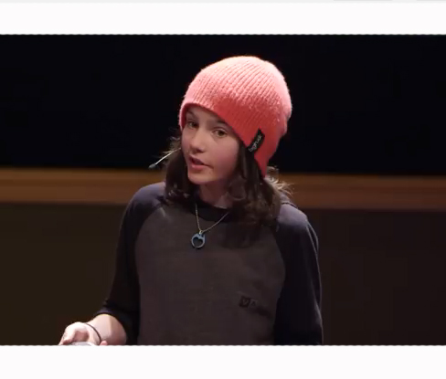

TED Talks Mentor Text Inquiry
Directions: Visit my website, Yanaenglish.weebly.com. Hover over TED Talks and click on the tab titled, Mentor Text Inquiry Resources. Use whatever resources you feel will help you explore a variety of TED Talks. As you watch the videos, record your observations in the space below. If you would like to continue this work in your notebook, record the information there. Happy watching!

Title of TED Talk | Rating (1-5) | What I really liked about this talk was… | Notes to self:  Inspiration/Ideas

Wrap-up: Move into some focused free writing:

- What topics are you gravitating towards?
- Why are you gravitating towards these topics?
- Are there any subtopics you may want to explore?

Quick Share:

- What were some things you saw in the talks today that you really enjoyed?
- What topics are you thinking of exploring?

Homework:
Independent Reading 4o mins.

Unit: Research / TED Talks Investigate Discern
EQ: What is “research”?

5/13
Aim: What is it about our world that makes you passionate?

Mind Spark:
- What videos did you watch for homework?
- What did you like about them?
- Any ideas for your own piece?

I ?

Strong researchers are passionate about the topic they study. They have a personal connection and a stake in their research.

- What is your topic of interest?
- What is your personal connection to this idea?
- Why are you interested in this?
- What experiences have brought you to this topic?

Take time to free-write and collect your thinking…

What do you already know about the topic… what else is there to know? If you’re stuck between several topics, use this chart to see which topic pushes you to ask the most interesting questions?

Example:

Topic | I know some things about this topic like… | Questions I have and topics I want to know more about:
Roman  Empire | Architecture  Inventions  Rulers/Emperors  YOU CAN ALSO FREEWRTE THIS PART… REALLY GETS THE IDEAS FLOWING | Tips!  Who?  What?  Where?  When?  Why?  What was the  social and family structure of Roman families?  What religion/gods did Romans worship? Did they go to a temple? How often?  What did school look like in the Roman Empire? Who got to go to school?

- Look at the questions you are wondering about. Identify your subtopics.
b) Reflect. What is the larger, overall topic that contains all your subtopics? What is a larger question you can ask to explore these subtopics?

Questions I have and topics I want to know more about:
What was the
social and family structure of Roman families?

(Subtopic: Family)

What religion/gods did Romans worship? Did they go to a temple? How often?
I’ve looked at my questions and it seems that I really want to know more about the everyday life of a Roman… I know the stuff we learned in history class, but I want to know what it was like to live a day as a Roman.

Preliminary Research Question:
How did Romans live their daily lives?

(Subtopic: Religion)

Who went to school? What was school like?

(Subtopic: Education/School )

Homework:
Please come in with a working research question.

Developing a research question:

Have a student

